**Assignment 20**

**Name:** Jeevan Sai Badana

**Mail:** jeevansai100@gmail.com

**Topic:** ADLS extraction and notes

**Date:** 16-02-2024

First we have create one storage account for this purpose and the name is adls23456 as below

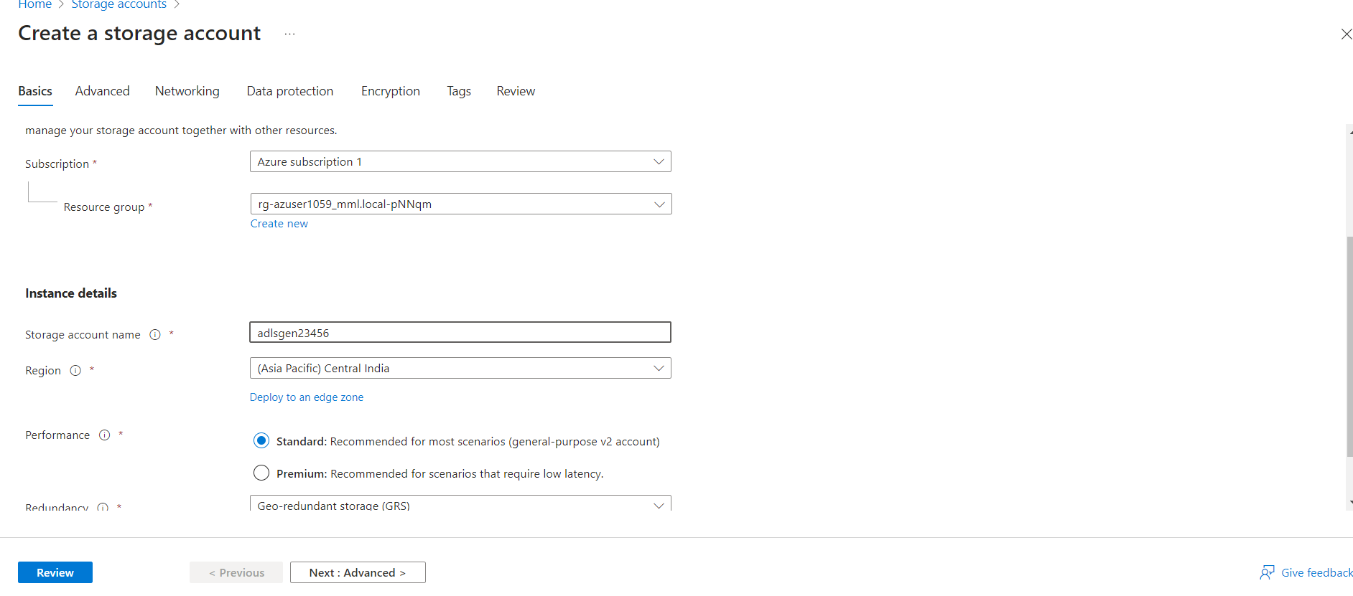

Now for data lake storage gen 2 we need to select the Hierarchical Namespace in advanced settings

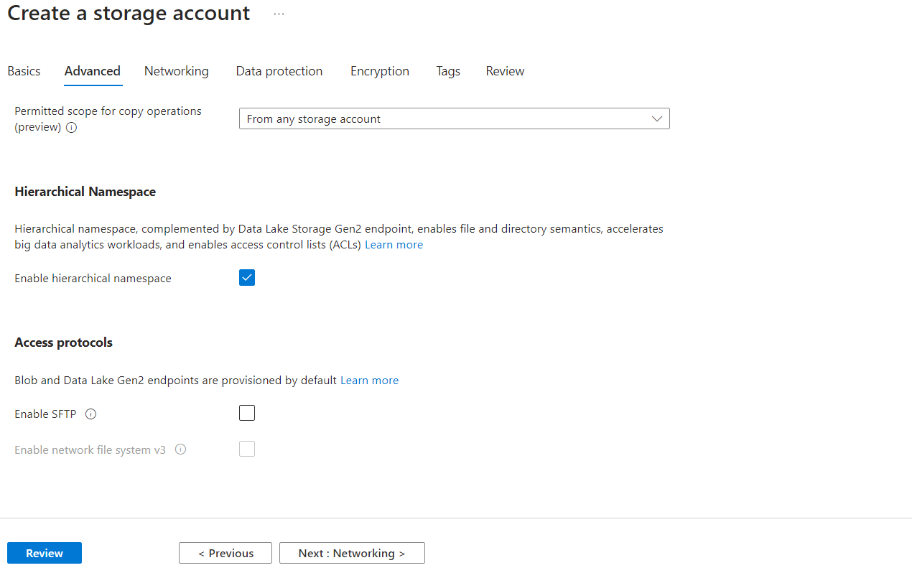

Now we can review and create

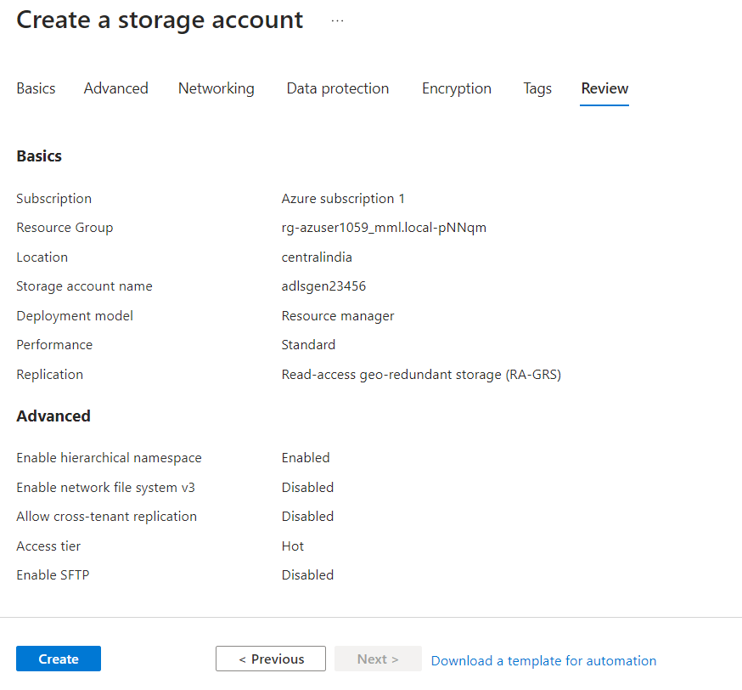

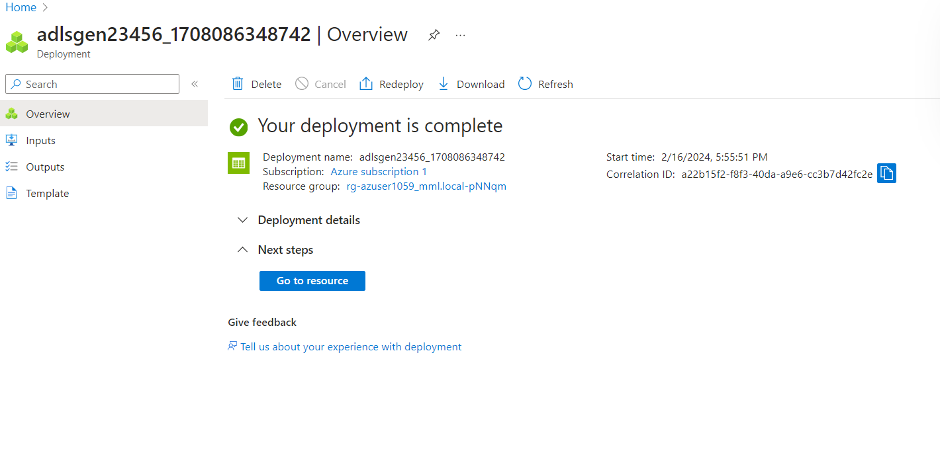

Now we go to resource and create container

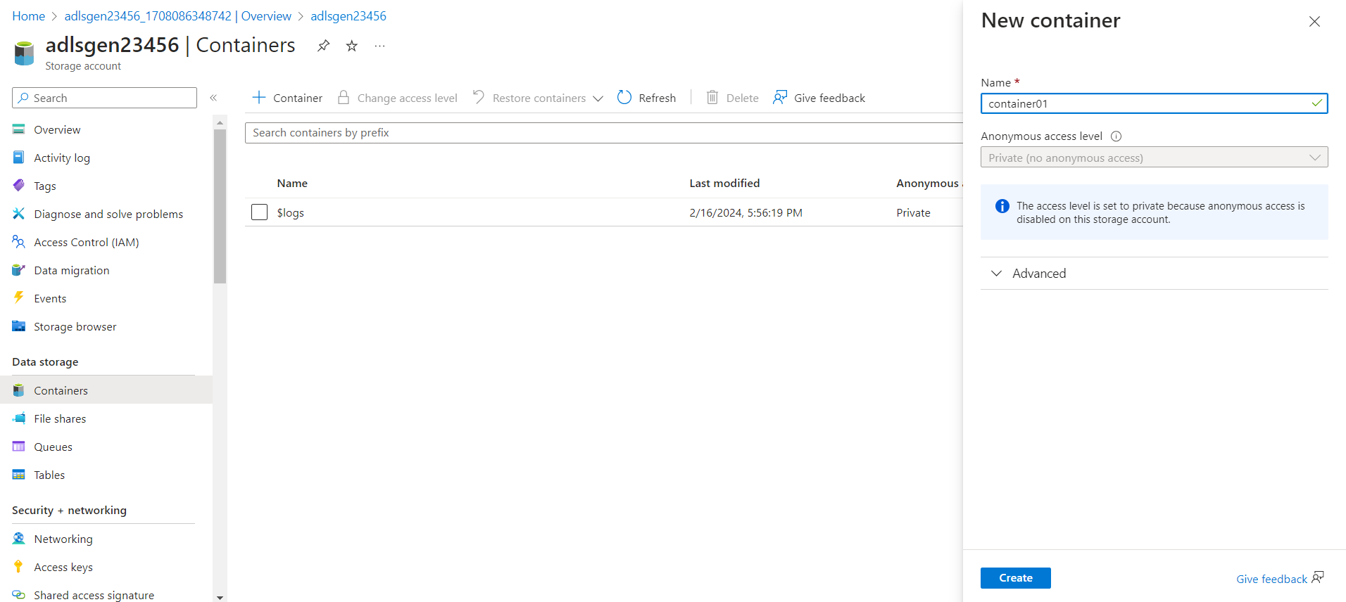

In container we upload one random file

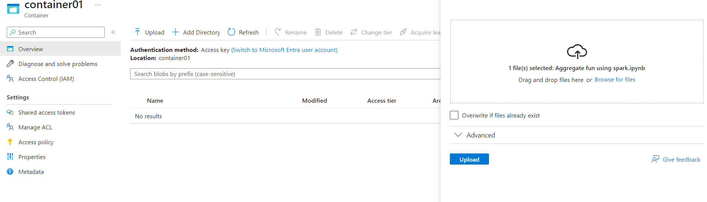

Now connect your Microsoft storage explorer

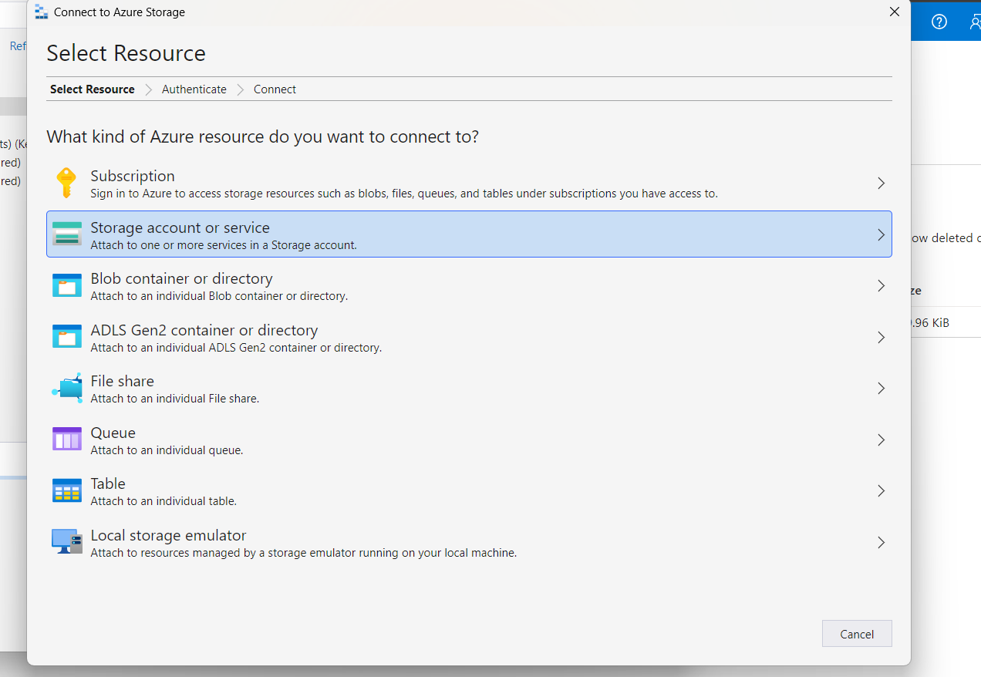

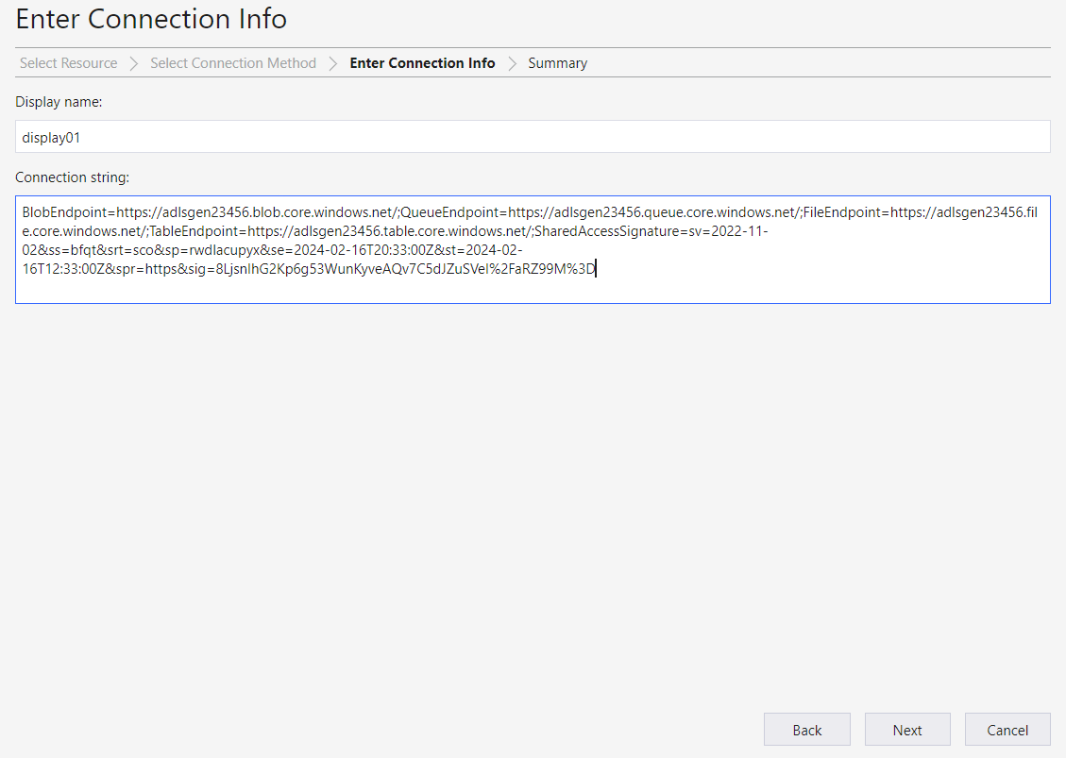

It connects successfully

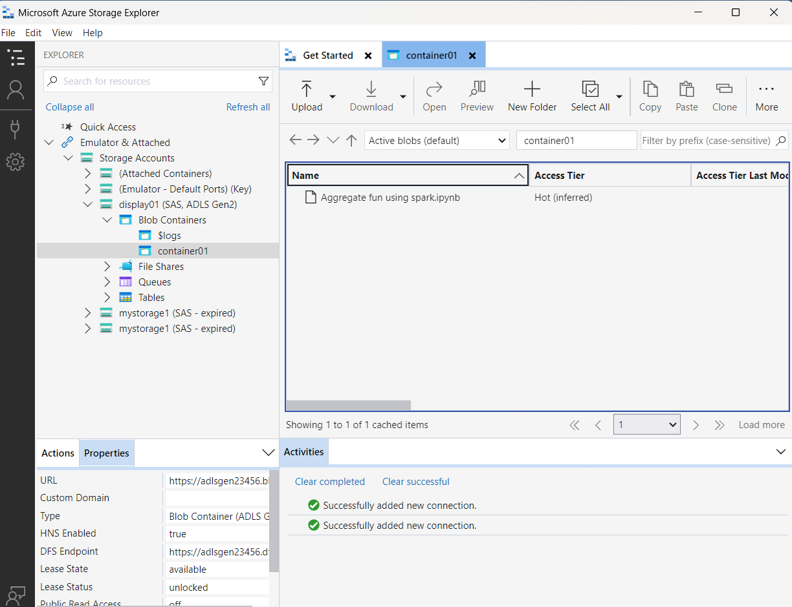

Running notes

ADLS extraction

